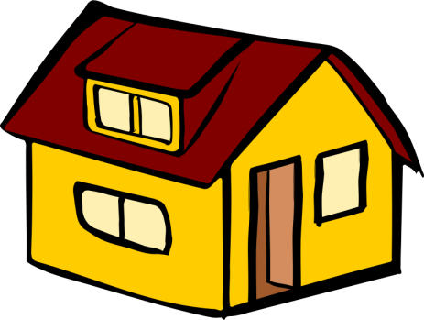
Name: Liveability
Definition:

Brainstorm: What makes a place liveable?

Factors that affect liveability:
Social
Cultural
Economic
Infrastructure
Environmental

